**Rest API using GET Method – ID added for 250 countries (JSON Server)**

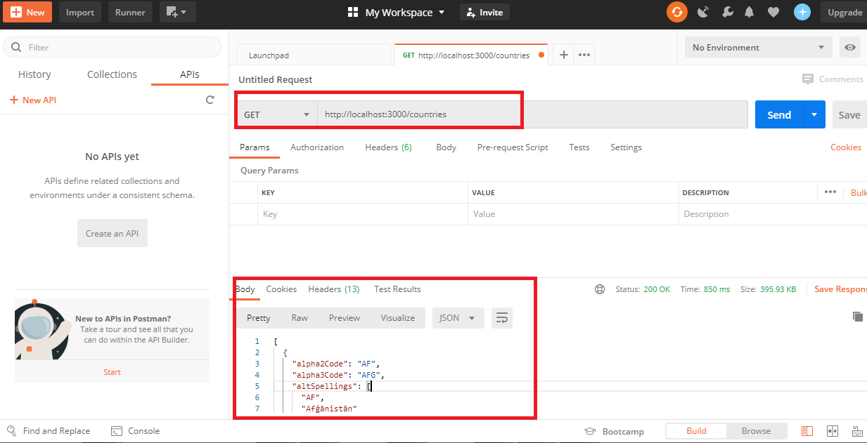

**Rest API using POST Method – ID added for 250 countries (JSON Server)**

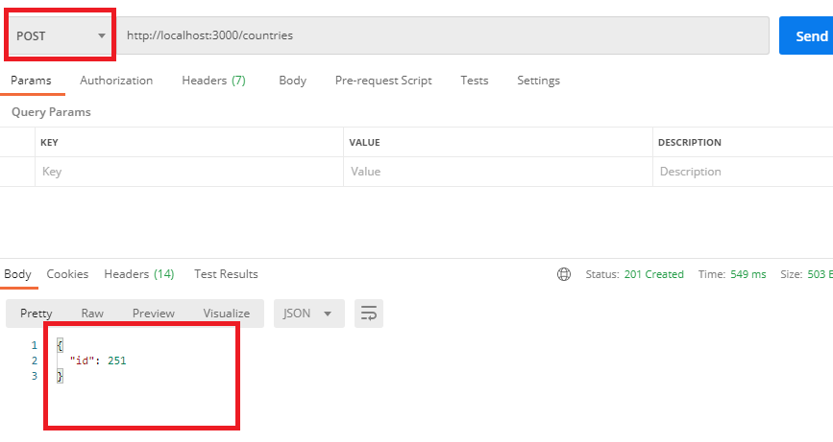

**Rest API using GET Method – Heroku**

<https://warm-anchorage-07817.herokuapp.com/countries>

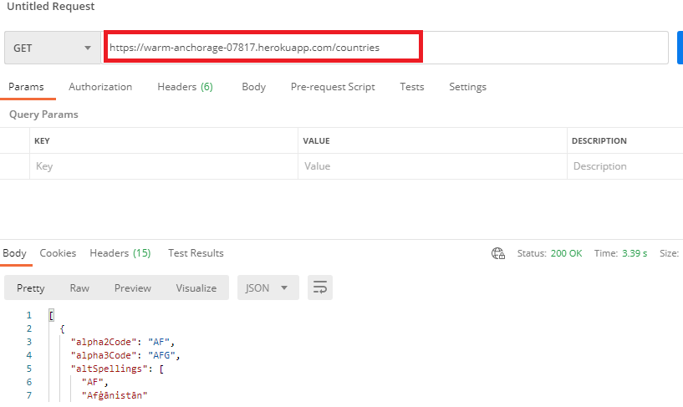

**Rest API using POST Method – Heroku**

